SAMPLE DATA INSERTION

1. Objective
The purpose of this task is to add sample category and product records to the ECommerceDB database and confirm that the data has been inserted correctly using SQL queries.

2. Select the Database
Before adding the sample records, the ECommerceDB database is selected for performing the insertion operations.
USE ECommerceDB;

3. Insert Sample Category Data
Four sample categories are added to the Category table to represent different types of products in the E-Commerce system.
INSERT INTO Category (Category_Name, Description)
VALUES
('Electronics', 'Electronic devices and accessories'),
('Clothing', 'Men and women clothing products'),
('Books', 'Educational and general books'),
('Home Appliances', 'Appliances used at home');

Inserted Categories
Category ID | Category Name | Description
1 | Electronics | Electronic devices and accessories
2 | Clothing | Men and women clothing products
3 | Books | Educational and general books
4 | Home Appliances | Appliances used at home
The above four categories are used as the sample category records for the Week 2 task.

Verification
The inserted category information can be checked using the following query:
SELECT * FROM Category;
Screenshot:
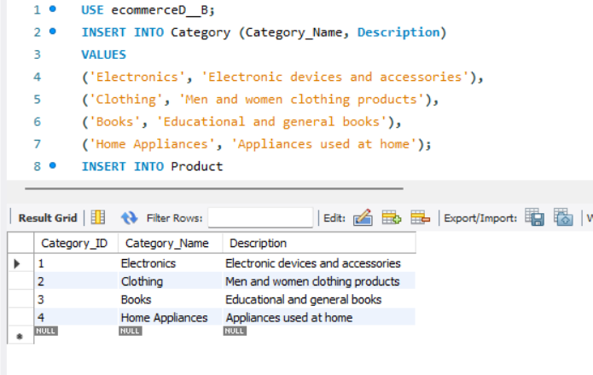

4. Insert Sample Product Data
A total of twelve sample products are inserted into the Product table. Each product is linked to its corresponding category through the Category_ID field.
INSERT INTO Product
(Product_Name, Category_ID, Price, Stock_Quantity)
VALUES
('Laptop', 1, 55000, 20),
('Smartphone', 1, 25000, 35),
('Bluetooth Headphones', 1, 1800, 60),
('Shoes', 2, 2500, 50),
('T-Shirt', 2, 600, 100),
('Jeans', 2, 1500, 40),
('The Alchemist', 3, 350, 75),
('Atomic Habits', 3, 450, 65),
('Data Structures Text', 3, 700, 30),
('Refrigerator', 4, 32000, 12),
('Washing Machine', 4, 28000, 10),
('Microwave Oven', 4, 9500, 18);

Sample Products
Product ID | Product Name | Category ID | Price | Stock
1 | Laptop | 1 | 55000 | 20
2 | Smartphone | 1 | 25000 | 35
3 | Bluetooth Headphones | 1 | 1800 | 60
4 | Shoes | 2 | 2500 | 50
5 | T-Shirt | 2 | 600 | 100
6 | Jeans | 2 | 1500 | 40
7 | The Alchemist | 3 | 350 | 75
8 | Atomic Habits | 3 | 450 | 65
9 | Data Structures Text | 3 | 700 | 30
10 | Refrigerator | 4 | 32000 | 12
11 | Washing Machine | 4 | 28000 | 10
12 | Microwave Oven | 4 | 9500 | 18
These twelve products form the sample product dataset for the Week 2 E-Commerce Database task. The category association is maintained using Category_ID.

Verification
The product records added to the database can be viewed using:
SELECT * FROM Product;
Screenshot:
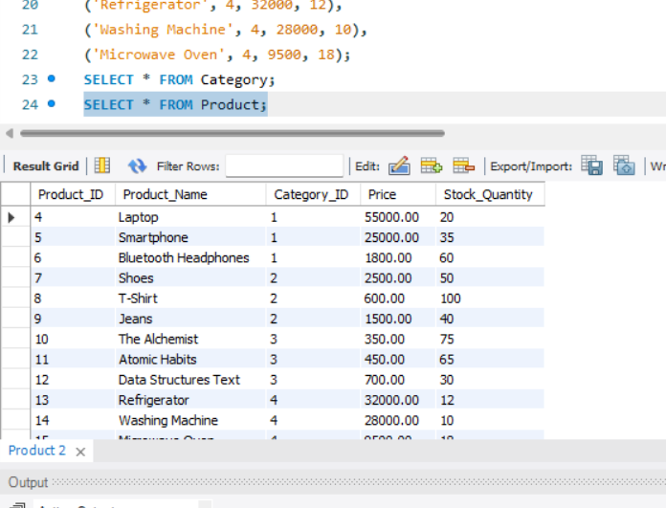

5. Result
The sample category and product records were successfully added to the ECommerceDB database. The inserted data was verified using SELECT queries, and the connection between the Category and Product tables was maintained through the Category_ID field.

